**MSSQL Adventure Works Database**

1. **Show the first name and the email address of customer with CompanyName 'Bike World’**

SELECT DISTINCT FirstName, EmailAddress

FROM SalesLT.Customer

WHERE CompanyName = 'Bike World';

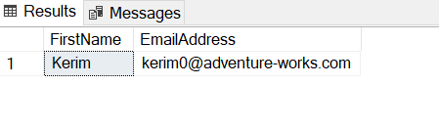

1. **Show the CompanyName for all customers with an address in City 'Dallas'.**

SELECT DISTINCT c.CompanyName

FROM SalesLT.Customer AS c

JOIN SalesLT.CustomerAddress AS ca

ON c.CustomerID = ca.CustomerID

JOIN SalesLT.Address AS a

ON ca.AddressID = a.AddressID

WHERE a.City = 'Dallas';

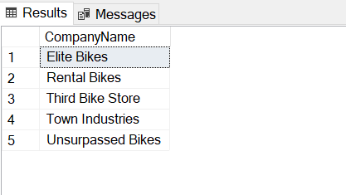

1. **How many items with ListPrice more than $1000 have been sold?**

SELECT COUNT(*) AS 'Number of Items'

FROM SalesLT.Product

WHERE ListPrice >= 1000;

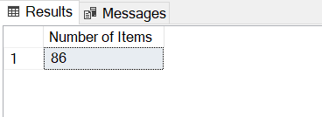

1. **Give the CompanyName of those customers with orders over $100000. Include the subtotal plus tax plus freight.**

SELECT c.CompanyName, oh.SubTotal + oh.TaxAmt + oh.Freight AS 'Total'

FROM SalesLT.Customer AS c

JOIN SalesLT.SalesOrderHeader AS oh ON c.CustomerID = oh.CustomerID

WHERE oh.SubTotal + oh.TaxAmt + oh.Freight > 100000;

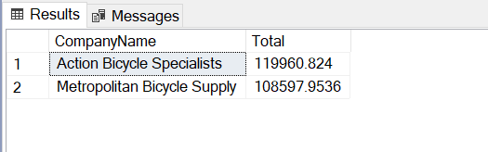

1. **Find the number of left racing socks ('Racing Socks, L') ordered by CompanyName 'Riding Cycles'**

SELECT SalesOrderDetail.OrderQty

FROM SalesLT.Product

JOIN SalesLT.SalesOrderDetail ON Product.ProductID = SalesOrderDetail.ProductID

JOIN SalesLT.SalesOrderHeader ON SalesOrderDetail.SalesOrderID = SalesOrderHeader.SalesOrderID

JOIN SalesLT.Customer ON SalesOrderHeader.CustomerID = Customer.CustomerID

WHERE Product.Name = 'Racing Socks, L' AND Customer.CompanyName = 'Riding Cycles';

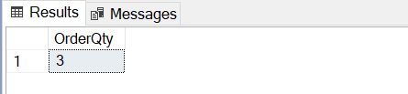

Top of Form